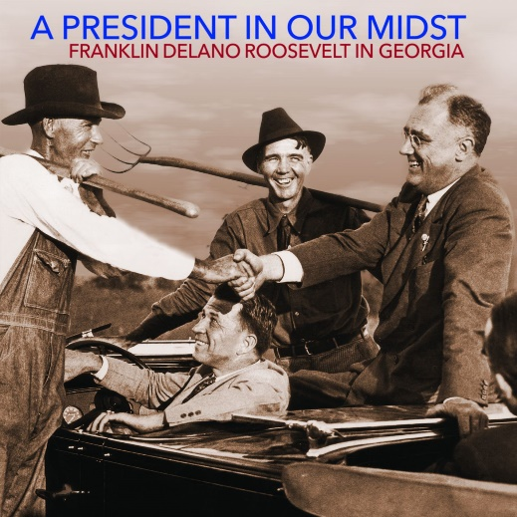
FOR IMMEDIATE RELEASE
Contact: Laura McCarty
ltmc@georgiahumanities.org

Documentary about How Georgia Influenced FDR to Air on GPB

(Atlanta, GA)— A new documentary, A President in Our Midst, will debut on Georgia Public Broadcasting’s statewide television network on Tuesday, September 21st at 7pm. The film shares stories of how Georgia and friendships with Georgians affected Franklin D. Roosevelt, as well as how President Roosevelt’s decisions and policies changed the state and left legacies.
The documentary is a collaboration of Georgia Humanities, Georgia State University Television, and Georgia Public Broadcasting. It is based on the award-winning book by Kaye Minchew, which the University of Georgia Press and Georgia Humanities co-published in 2016.
Communities featured include Athens, Atlanta, Barnesville, Brunswick, Gainesville, LaGrange, Savannah, Thomaston, and Warm Springs. The film also touches on several campuses, including the Atlanta University Center, Georgia Tech, Gordon College, and University of Georgia.
The film has been made possible by the individual, foundation, and corporate donors who provided funds to support its production. Major organizational contributors include Explore Georgia; the Georgia Division of Parks, Recreation and Historic Sites-Georgia Department of Natural Resources; Georgia EMC; Friends of Georgia State Parks and Historic Sites; LCP Wealth Management of LaGrange; Passive Solar Design, Inc.; Pig & Possum Inc.; and the Rural Library Project. In addition, more than 70 Georgians collaborated and shared their professional services as actors, directors, photographers, production personnel, or scholar interviews. Carol Howington Cain, James Fowler, and Bill Murray are featured performers in the documentary.
Georgia Humanities invites you to gather with family and friends to watch the film. Send us your comments on social media using #FDRinGeorgia.
After the viewing, the film will be available through the Georgia Public Broadcasting Education portal. Public libraries will be receiving copies of the film. If you are interested in a program for your community, contact Laura McCarty at ltmc [at] georgiahumanities.org.

About Georgia Humanities
Georgia Humanities promotes and preserves the stories and cultural legacies of the state’s people—from the past to the present and into the future—to enrich our lives and strengthen our communities. An informed and educated Georgia understands historical and cultural trends, respects the life of the mind, utilizes critical thinking in decision-making, and promotes mutual respect and civility. Funding for Georgia Humanities is provided by the Georgia General Assembly, the National Endowment for the Humanities, foundations, donors, and partners. For more information, visit GeorgiaHumanities.org.
###

